**Name:** Chandana Ramesh Galgali

**Batch:** P6-1 **Roll No.:** 16010422234

**Date:** 12 May 2023

**Experiment No. 4**

**Title:**  Water Analysis

**Aim:**  To determine chemical parameters such as hardness, alkalinity of water samples.

**Procedure:**

a. Determination of Hardness of Water Sample

1. Select the titrant.
2. Adjust the speed of the drops from the burette.
3. Adjust the molarity of titrant.
4. Select a definite volume of water sample.
5. Choose the indicator & start the titration.
6. When colour changes from wine red to blue click the "stop" button & note the volume of EDTA used.
7. Then calculate the hardness of the water sample in ppm using the equation as follows.
8. Hardness:



**Observations:**

Burette : EDTA Solution (Molarity of the titrant = 0.01)

Conical flask : 10 mL of (Titrate like Well water, Tap water, Sea water) + Eriochrome Black T + Buffer of pH 10

Indicator : Eriochrome Black T

End point : Wine red to blue

**Observation Table: (Well Water)**

# Pilot Reading : 1 (mL) to 2 (mL)

| Reading | I (mL) | II (mL) | III (mL) | Constant (mL) |
| --- | --- | --- | --- | --- |
| Initial | 50 | 50 | 50 | V1= 2.5 |
| Final | 47.5 | 47.5 | 47.5 |
| Difference | 2.5 | 2.5 | 2.5 |

**Observation Table: (Tap Water)**

# Pilot Reading : 1 (mL) to 2 (mL)

| Reading | I (mL) | II (mL) | III (mL) | Constant (mL) |
| --- | --- | --- | --- | --- |
| Initial | 50 | 50 | 50 | V1= 1.5 |
| Final | 48.5 | 48.5 | 48.5 |
| Difference | 1.5 | 1.5 | 1.5 |

**Observation Table: (Sea Water)**

# Pilot Reading : 1 (mL) to 2 (mL)

| Reading | I (mL) | II (mL) | III (mL) | Constant (mL) |
| --- | --- | --- | --- | --- |
| Initial | 50 | 50 | 50 | V1= 6 |
| Final | 44 | 44 | 44 |
| Difference | 6 | 6 | 6 |

**Snapshots of the simulation:**

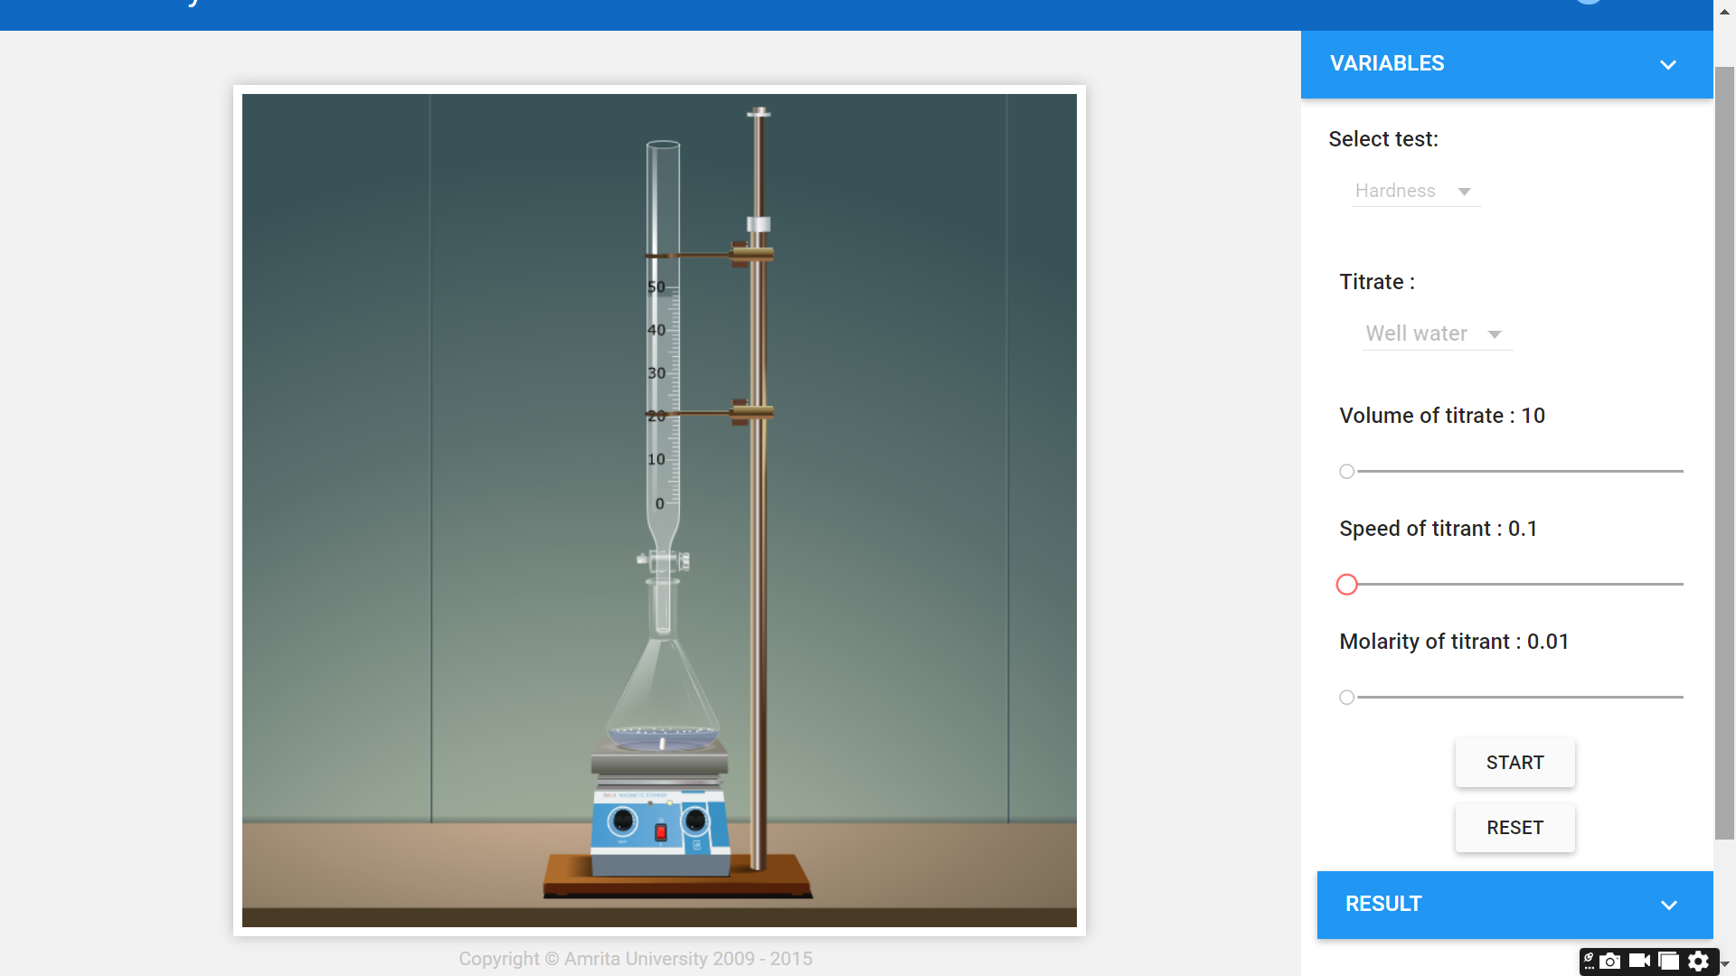

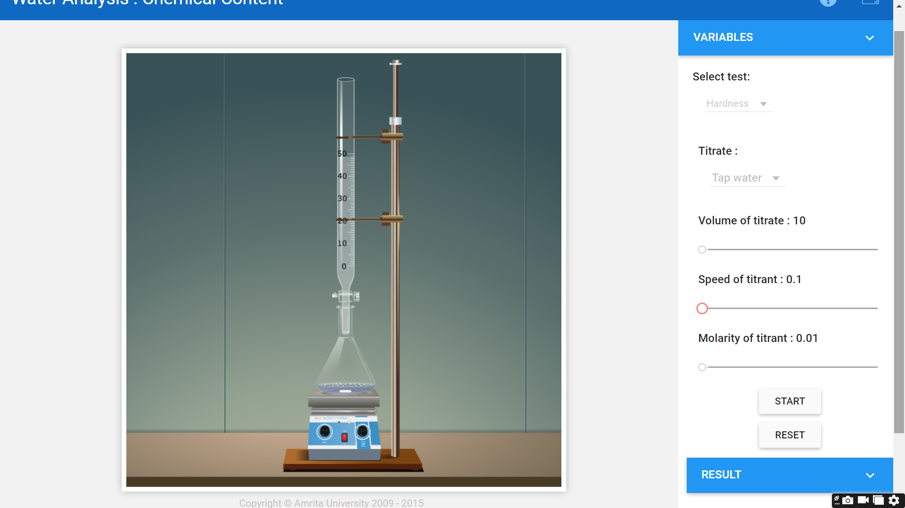

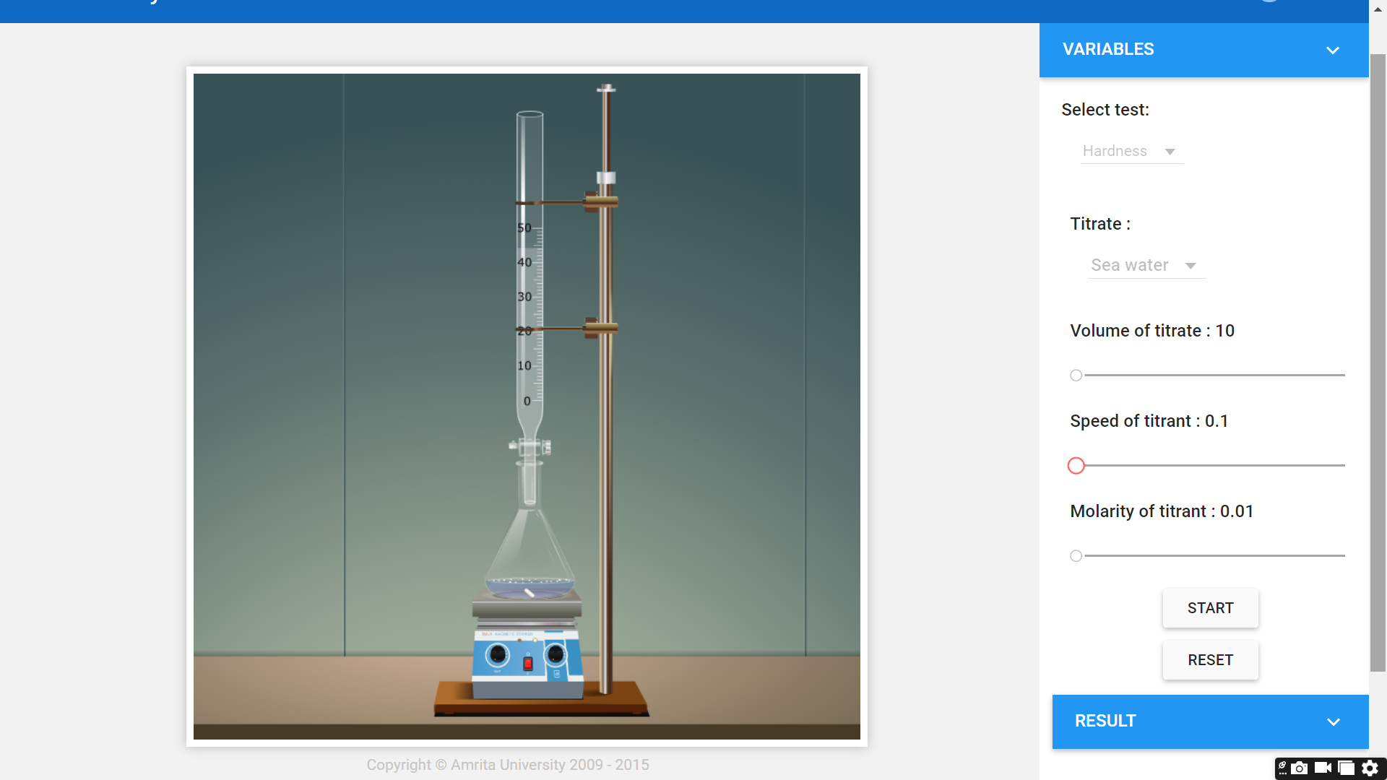

**Calculations:**

Well Water :

Tap Water :

Sea Water :

**Result:**

Hardness of water :

| Sr. No. | Sample | Hardness in ppm | Inference |
| --- | --- | --- | --- |
| 1. | Well water | 250 | It was harder than tap water but less harder than sea water. |
| 2. | Tap water | 150 | It was the least hard as compared to well and sea water. |
| 3. | Sea Water | 600 | It was the hardest as compared to tap and well water. |

**Self Evaluation:**

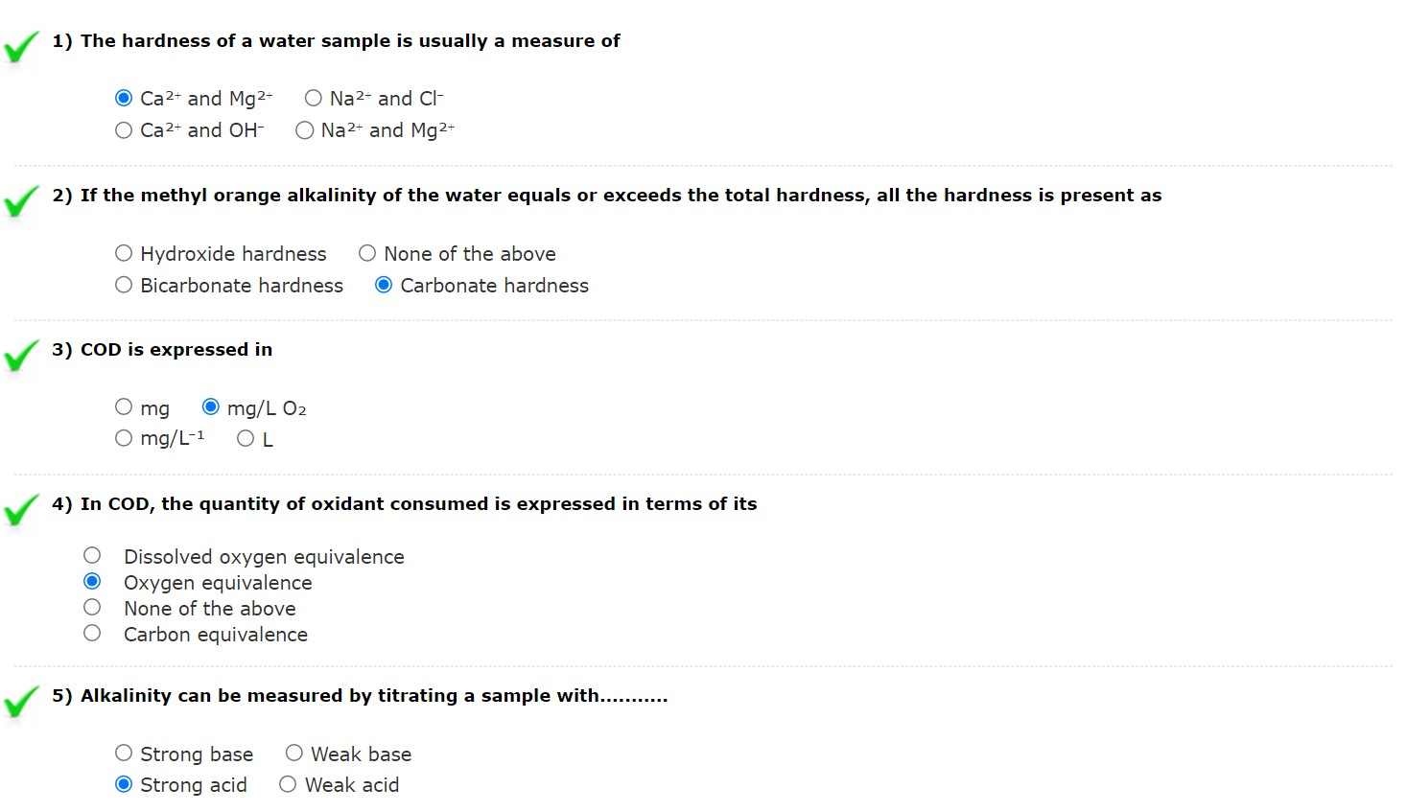

**Assignments:**

1. 100 mL of water sample on titration with N/50 H2SO4, using phenolphthalein as indicator, gave the end point when 50 mL of acid were run down. Another aliquot of 100 mL of the sample also required 5.0 mL of the acid to obtain methyl orange end point. What is the type of alkalinity present in the sample?

Ans: To determine the type of alkalinity present in the water sample, we need to analyze the results of the titration with both phenolphthalein and methyl orange indicators.

Phenolphthalein end point: This indicates the presence of hydroxides (OH⁻) and half of the carbonates (CO₃²⁻) in the sample. The volume of N/50 H₂SO₄ used for this endpoint is 50 mL.

Methyl orange end point: This indicates the presence of all the carbonates (CO₃²⁻) and bicarbonates (HCO₃⁻) in the sample. The volume of N/50 H₂SO₄ used for this endpoint is 5.0 mL.

Now, let's calculate the difference in the volume of acid used for both endpoints:

Difference = Volume of acid for methyl orange end point - Volume of acid for phenolphthalein end point

Difference = 5.0 mL - 50 mL = -45 mL

Since the difference is negative, it means that the phenolphthalein end point consumed more acid than the methyl orange end point. This indicates that the sample contains hydroxides (OH⁻) and carbonates (CO₃²⁻), but no bicarbonates (HCO₃⁻). Therefore, the type of alkalinity present in the sample is a combination of hydroxide and carbonate alkalinity.

2. The hardness of 1000 litres of a water sample was completely removed by a zeolites softener. The zeolites had required 30 litres of NaCl solution, containing 1,500mg/L of NaCl for regeneration. Calculate the hardness of the water sample?

Ans: To calculate the hardness of the water sample, we need to determine the amount of NaCl used for regeneration and then relate it to the amount of hardness removed.

First, let's calculate the total mass of NaCl used for regeneration:

Mass of NaCl = Volume of NaCl solution × Concentration of NaCl

Mass of NaCl = 30 L × 1,500 mg/L

Mass of NaCl = 45,000 mg

In the zeolite softener, NaCl is used to replace the hardness-causing ions (Ca²⁺ and Mg²⁺) that are adsorbed by the zeolite. The reaction can be represented as:

Na⁺ + Zeolite-Ca²⁺/Mg²⁺ → Zeolite-Na⁺ + Ca²⁺/Mg²⁺

Since the reaction is 2:1 for Na⁺ to Ca²⁺/Mg²⁺, we can calculate the mass of hardness-causing ions removed:

Mass of Ca²⁺/Mg²⁺ = (Mass of NaCl / 2) × (Molar mass of CaCO₃ / Molar mass of NaCl)

Assuming the hardness is primarily due to Ca²⁺ ions, we can use the molar mass of CaCO₃ (100.09 g/mol) and NaCl (58.44 g/mol) for the calculation:

Mass of Ca²⁺/Mg²⁺ = (45,000 mg / 2) × (100.09 g/mol / 58.44 g/mol)

Mass of Ca²⁺/Mg²⁺ = 22,500 mg × (100.09 / 58.44)

Mass of Ca²⁺/Mg²⁺ = 38,543.5 mg

Now, let's calculate the hardness of the water sample in mg/L as CaCO₃:

Hardness (mg/L as CaCO₃) = (Mass of Ca²⁺/Mg²⁺) / Volume of water sample

Hardness (mg/L as CaCO₃) = 38,543.5 mg / 1,000 L

Hardness (mg/L as CaCO₃) = 38.54 mg/L

Therefore, the hardness of the water sample is approximately 38.54 mg/L as CaCO₃.

3. What is alkalinity and why is it important? Discuss.

Ans: Alkalinity is a measure of water’s ability to resist [pH](https://www.wwdmag.com/editorial-topical/what-is-articles/article/10940015/what-is-ph) changes that lead to acidity, or to neutralize acids, and maintain a fairly stable pH. This ability is usually referred to as water’s “buffering capacity”. The presence of certain chemicals, including hydroxides, carbonates, and bicarbonates, affects water’s alkalinity. In simple terms, water with high alkalinity is less prone to becoming more acidic if it is contaminated with acidic water, such as acid rain. Alkalinity is important for the health and welfare of ecosystems, marine life, and humans. The organisms that live in natural water sources are not adapted to living in rapidly changing water conditions. Before industrialization, aquatic organisms lived in waters that had consistent pH and other parameters. There was no acid rain, no chemical spills, no wastewater effluent, and nothing else that could affect the quality of a water source. Nowadays, there are numerous causes of rapid pH change. Aquatic organisms thrive in a pH range of 6.0 to 9.0. When water’s pH changes suddenly, the aquatic organisms may become stressed or diseased, or die. Alkalinity is also essential for wastewater and drinking water treatment. Water treatment generates hydrogen ions, and alkalinity is needed to ensure pH remains in the optimal range. If the alkalinity level in water is too low, excess hydrogen remains, causing the pH to drop and reduce the speed of water treatment. Very low alkalinity may even cause the treatment process to stop altogether. Water treatment facilities use soda ash to raise pH and alkalinity, which are added progressively until the desired alkalinity range is achieved.

4. What are the water quality standards for alkalinity?

Ans: The CCC of 20 mg/L is a minimum value except where alkalinity is naturally lower, in which case the criterion is the natural alkalinity of the water in question. Where natural alkalinity is > 20 mg/L, the criterion cannot be lower than 25% of the natural level, or 20 mg/L whichever is higher.

5. A water sample is not alkaline to phenolphthalein. However 100 mL of the sample, on titration with N/50 HCl, required 16.9 mL to obtain the end point, using methyl orange as indicator. What is the amount of alkalinity present in the sample?

Ans: Since the water sample is not alkaline to phenolphthalein, it means that there are no hydroxides (OH⁻) or carbonates (CO₃²⁻) present in the sample. The presence of alkalinity in this case is due to bicarbonates (HCO₃⁻).

To calculate the amount of alkalinity present in the sample, we can use the volume of N/50 HCl required to obtain the methyl orange end point, which is 16.9 mL.

The reaction between HCl and HCO₃⁻ can be represented as:

HCl + HCO₃⁻ → H₂O + CO₂ + Cl⁻

Since the reaction is 1:1, the amount of HCO₃⁻ in the sample can be calculated using the volume of HCl used:

Amount of HCO₃⁻ (meq) = Volume of HCl (mL) × Normality of HCl

Amount of HCO₃⁻ (meq) = 16.9 mL × (1/50) N

Amount of HCO₃⁻ (meq) = 0.338 meq

To express the alkalinity in terms of mg/L as CaCO₃, we can use the following conversion factor:

1 meq of alkalinity = 50 mg/L as CaCO₃

Alkalinity (mg/L as CaCO₃) = Amount of HCO₃⁻ (meq) × 50 mg/L

Alkalinity (mg/L as CaCO₃) = 0.338 meq × 50 mg/L

Alkalinity (mg/L as CaCO₃) = 16.9 mg/L

Therefore, the amount of alkalinity present in the 100 mL water sample is 16.9 mg/L as CaCO₃.